/clinic-agent/
├── app_with_chatgpt_agent.py
├── doctors.txt
├── doctor_map.json
├── admin_numbers.txt
├── credentials.json ← your Google service account
- Install Packages
- sudo apt update
- sudo apt install python3 python3-pip -y
- pip3 install flask openai twilio google-api-python-client google-auth google-auth-oauthlib python-dotenv google-auth-oauthlib
- Create Project Directories
- mkdir -p ~/epic_voice_assistant
- cd ~/epic_voice_assistant

- Configuration Files

- doctors.txt
This file contains one Google Calendar ID per doctor, one per line:
- clinic_doctor_1_calendar_id@group.calendar.google.com
- clinic_doctor_2_calendar_id@group.calendar.google.com

- doctor_map.json

This file maps the calendar IDs to the doctor names the AI will use in voice responses:
{
"clinic_doctor_1_calendar_id@group.calendar.google.com": "Dr. Sara",
"clinic_doctor_2_calendar_id@group.calendar.google.com": "Dr. Ali"
}
- admin_numbers.txt
- list phone numbers (in international format) to receive voicemail alerts:
- +1234567890
- +1987654321

- Set Environment Variables
✅ 1. Create .env file
In the root folder of your Flask project, create a file called .env:
nano /home/ubuntu/app/.env
Paste the following inside:
OPENAI_API_KEY=sk-xxxxxxxxxxxxxxxxxxxxxxxxxxxxxxxxxxxxxxxx
TWILIO_ACCOUNT_SID=ACxxxxxxxxxxxxxxxxxxxxxxxxxxxxxxxx
TWILIO_AUTH_TOKEN=your_auth_token_here
Save and close with Ctrl+O, Enter, then Ctrl+X.

- Save Python Script
Save your script as app.py in the same folder:
nano ~/epic_voice_assistant/app.py
Paste the complete script provided earlier with ChatGPT-based dynamic response, Google Calendar, and Twilio voice assistant logic.
- Create systemd Service
Create a service file:
sudo nano /etc/systemd/system/epicbot.service

[Unit]
Description=Epic Voice Assistant Flask App
After=network.target

[Service]
User=ubuntu
WorkingDirectory=/home/ubuntu/epic_voice_assistant
ExecStart=/usr/bin/python3 app.py
Restart=always
Environment=OPENAI_API_KEY=sk-xxxxxxxx
Environment=TWILIO_ACCOUNT_SID=ACxxxxxxxx

Environment=TWILIO_AUTH_TOKEN=xxxxxxxx
Environment=TWILIO_NUMBER=+15551234567

[Install]
WantedBy=multi-user.target
Enable and start:
sudo systemctl daemon-reload
sudo systemctl enable epicbot
sudo systemctl start epicbot
Check status:
sudo systemctl status epicbot

- Allow Port 80 on Azure
Go to your Azure portal:
- Network Security Group → Inbound Rules
  - Allow TCP port 80
  - Source: Any
  - Destination: Your VM
  - Action: Allow
- Point Twilio to Your Server
- Go to Twilio Console > Phone Numbers
- Click your number
- Under Voice → A CALL COMES IN, choose:
  - Webhook: http://<YOUR_PUBLIC_IP>/voice
  - Method: POST
- Step-by-Step: How to Create credentials.json for Google Calendar API
🔹 1. Go to Google Cloud Console
🔗 Visit: https://console.cloud.google.com/

🔹 2. Create a New Project
- Click "Select project" → "New Project"
- Give it a name like Clinic Voice Assistant
- Click "Create"

🔹 3. Enable Google Calendar API
- In the top search bar, type: "Google Calendar API"
- Click it, then click "Enable"
🔹 4. Create a Service Account

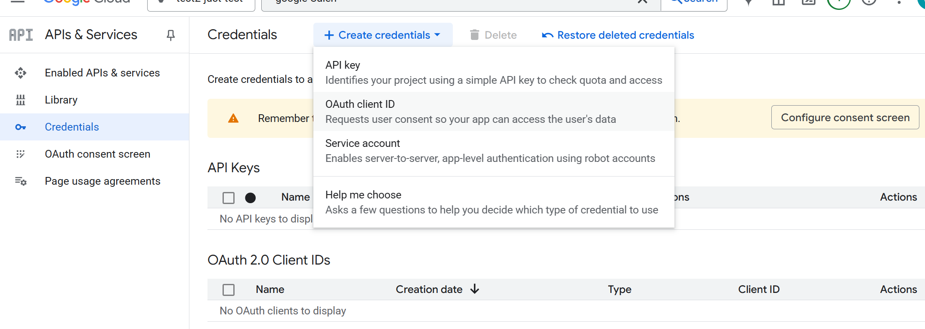
- In the left menu → Go to "APIs & Services" > "Credentials"
- Click "Create Credentials" > "Service Account"
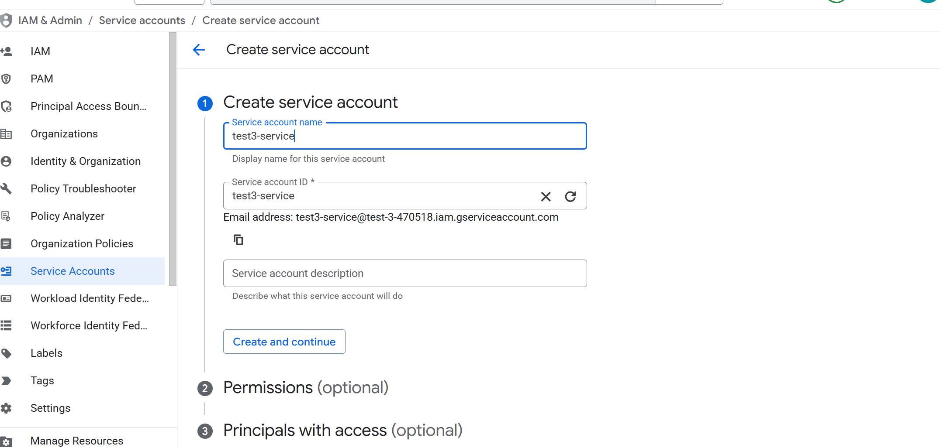
- Fill up the name
- Click Continue and continue->select role _>owner
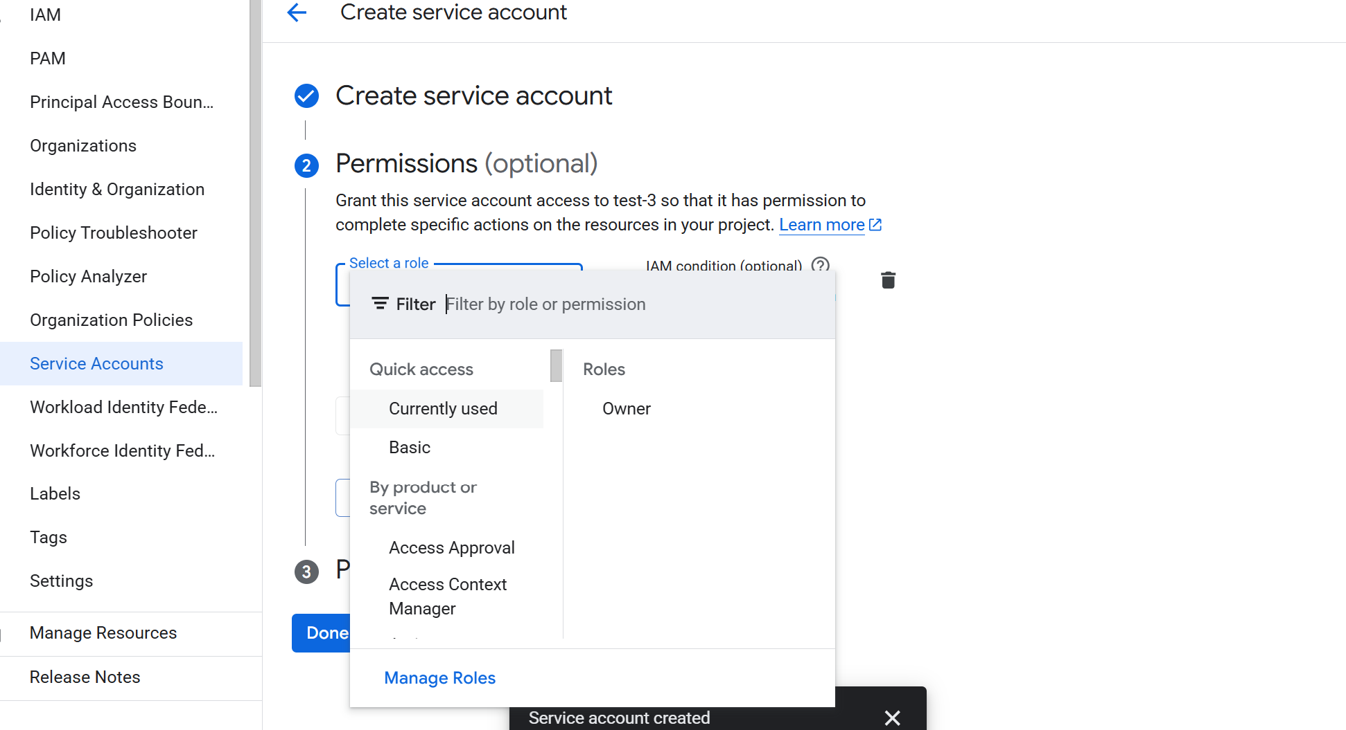

🔹 5. Create and Download JSON Key
Click pencil red arrow
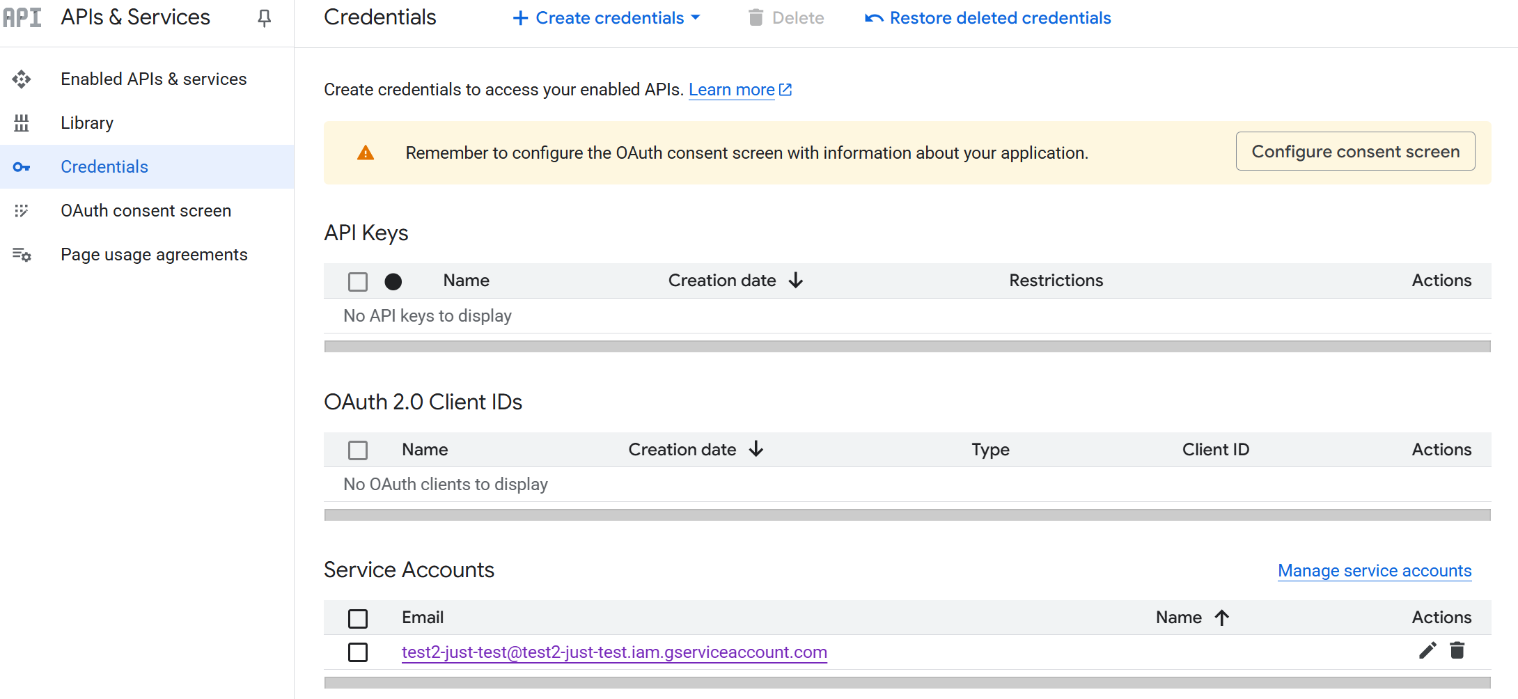
- Once the service account is created,
- Go to "Keys" tab
- Click "Add Key" > "Create new key"
- Choose JSON
- It will download a file like:
calendar-bot-abc123.json
✅ Rename this file to credentials.json
✅ Place it in the same folder as your Python script

🔹 6. Share Calendar Access with the Service Account
- Open Google Calendar for each doctor. Calendar.google.com
- Click the ⚙️ Settings > Settings for [doctor’s calendar]
- Scroll to "Share with specific people"
- Add the service account email (e.g., calendar-bot@your-project.iam.gserviceaccount.com)
- Give it "Make changes to events" permission.
✅ Done!
Now the Python script can use this service account to:
- Check appointment availability
- Add new appointments

Twilio Configuration with GoDaddy + Ubuntu + Nginx + Certbot
- GoDaddy DNS Setup
In GoDaddy DNS settings for your domain (e.g., funlearning4u.com):
@ record → A record → Value: your VM public IP
www record → A record → Value: same VM public IP
Wait a few minutes to an hour for propagation.

- Open Firewall (Azure NSG or VM security group)
Allow inbound:
TCP 80 (HTTP)
TCP 443 (HTTPS)

- Install Required Packages
sudo apt update
sudo apt install nginx certbot python3-certbot-nginx -y

- Temporary HTTP Nginx Config
Create:
sudo nano /etc/nginx/sites-available/funlearning4u.com
server {
listen 80;
server_name funlearning4u.com www.funlearning4u.com;

location / {
proxy_pass http://127.0.0.1:5000;
proxy_set_header Host $host;
proxy_set_header X-Real-IP $remote_addr; // address of client making request
proxy_set_header X-Forwarded-For $proxy_add_x_forwarded_for;
}
}
Enable & reload:
sudo ln -s /etc/nginx/sites-available/funlearning4u.com /etc/nginx/sites-enabled/
sudo nginx -t
sudo systemctl reload nginx

- Get SSL Certificate
sudo certbot --nginx -d funlearning4u.com -d www.funlearning4u.com
Choose redirect HTTP → HTTPS when prompted.

- Final Nginx Config
server {
listen 80;
server_name funlearning4u.com www.funlearning4u.com;
return 301 https://$host$request_uri;
}

server {
listen 443 ssl;
server_name funlearning4u.com www.funlearning4u.com;

ssl_certificate /etc/letsencrypt/live/funlearning4u.com/fullchain.pem;
ssl_certificate_key /etc/letsencrypt/live/funlearning4u.com/privkey.pem;

location / {
proxy_pass http://127.0.0.1:5000;
proxy_set_header Host $host;
proxy_set_header X-Real-IP $remote_addr;
proxy_set_header X-Forwarded-For $proxy_add_x_forwarded_for;
}
}
Test & reload:
sudo nginx -t
sudo systemctl reload nginx

- SSL Auto-Renew
Certbot auto-renews via systemd timer. Check:
systemctl list-timers | grep certbot
Test renewal:
sudo certbot renew --dry-run

- (Optional) Run Flask App as a Service
Create file:
sudo nano /etc/systemd/system/flaskapp.service
[Unit]
Description=Flask App Service
After=network.target

[Service]
User=ubuntu
WorkingDirectory=/home/ubuntu/app
ExecStart=/usr/bin/python3 app.py
Restart=always

[Install]
WantedBy=multi-user.target
Enable & start:
sudo systemctl daemon-reload
sudo systemctl enable flaskapp
sudo systemctl start flaskapp

Final Twilio Webhook URL (for Console Setup)

Phone Numbers | Twilio Console

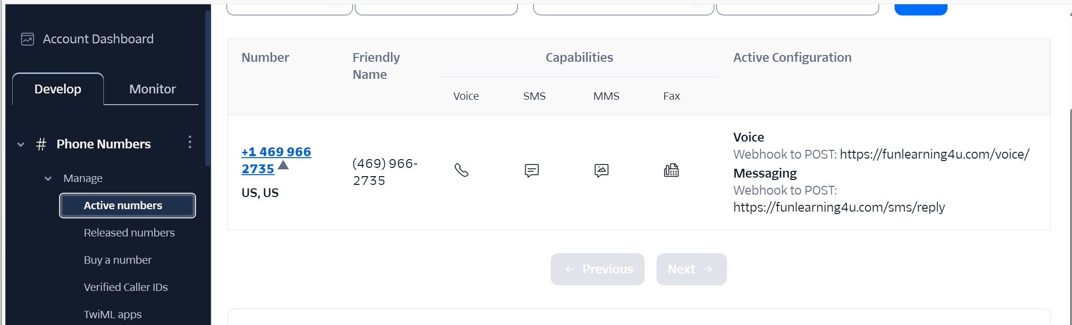
Click on number

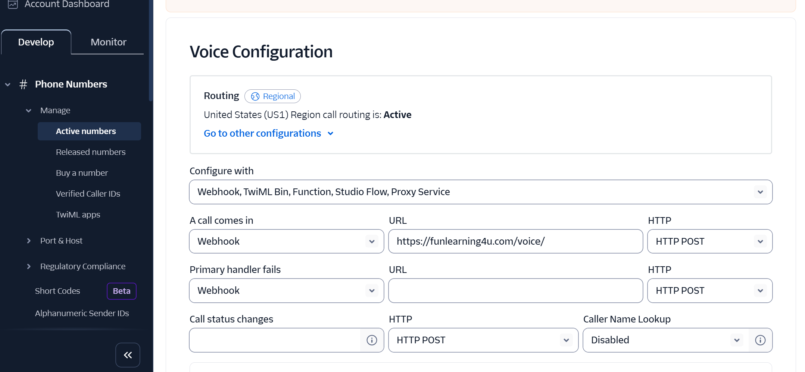

SMS Section: after voice
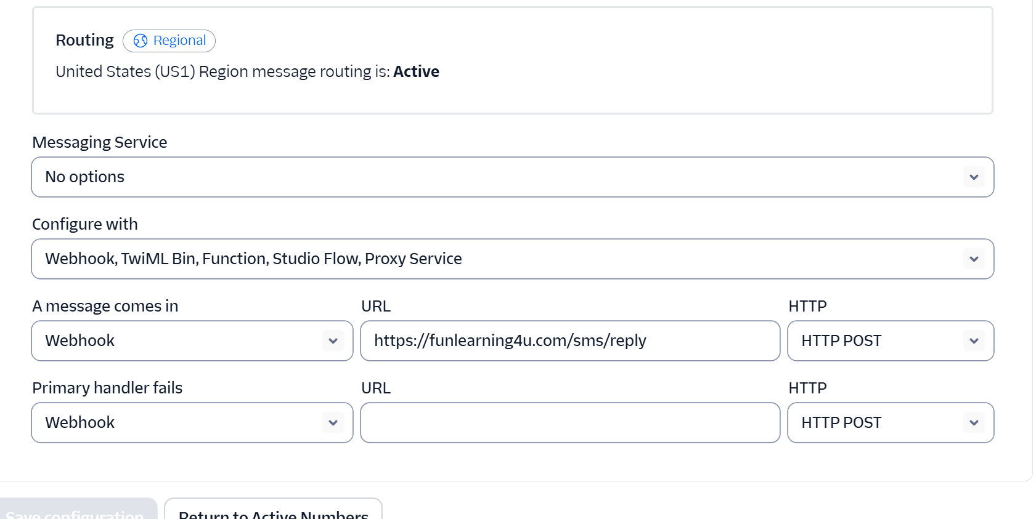

Voice URL:
https://funlearning4u.com/voice```
Fallback URL (optional):
https://funlearning4u.com/fallback```
SMS URL (if used):
https://funlearning4u.com/sms```
Done! Your Flask app is now secured with HTTPS, auto-renewable, and integrated with Twilio.

GoDaddy Configuration
https://sso.godaddy.com

🛠️ Step-by-Step: Set A Record in GoDaddy
- Login to GoDaddy
Go to: https://dcc.godaddy.com/manage and sign in.
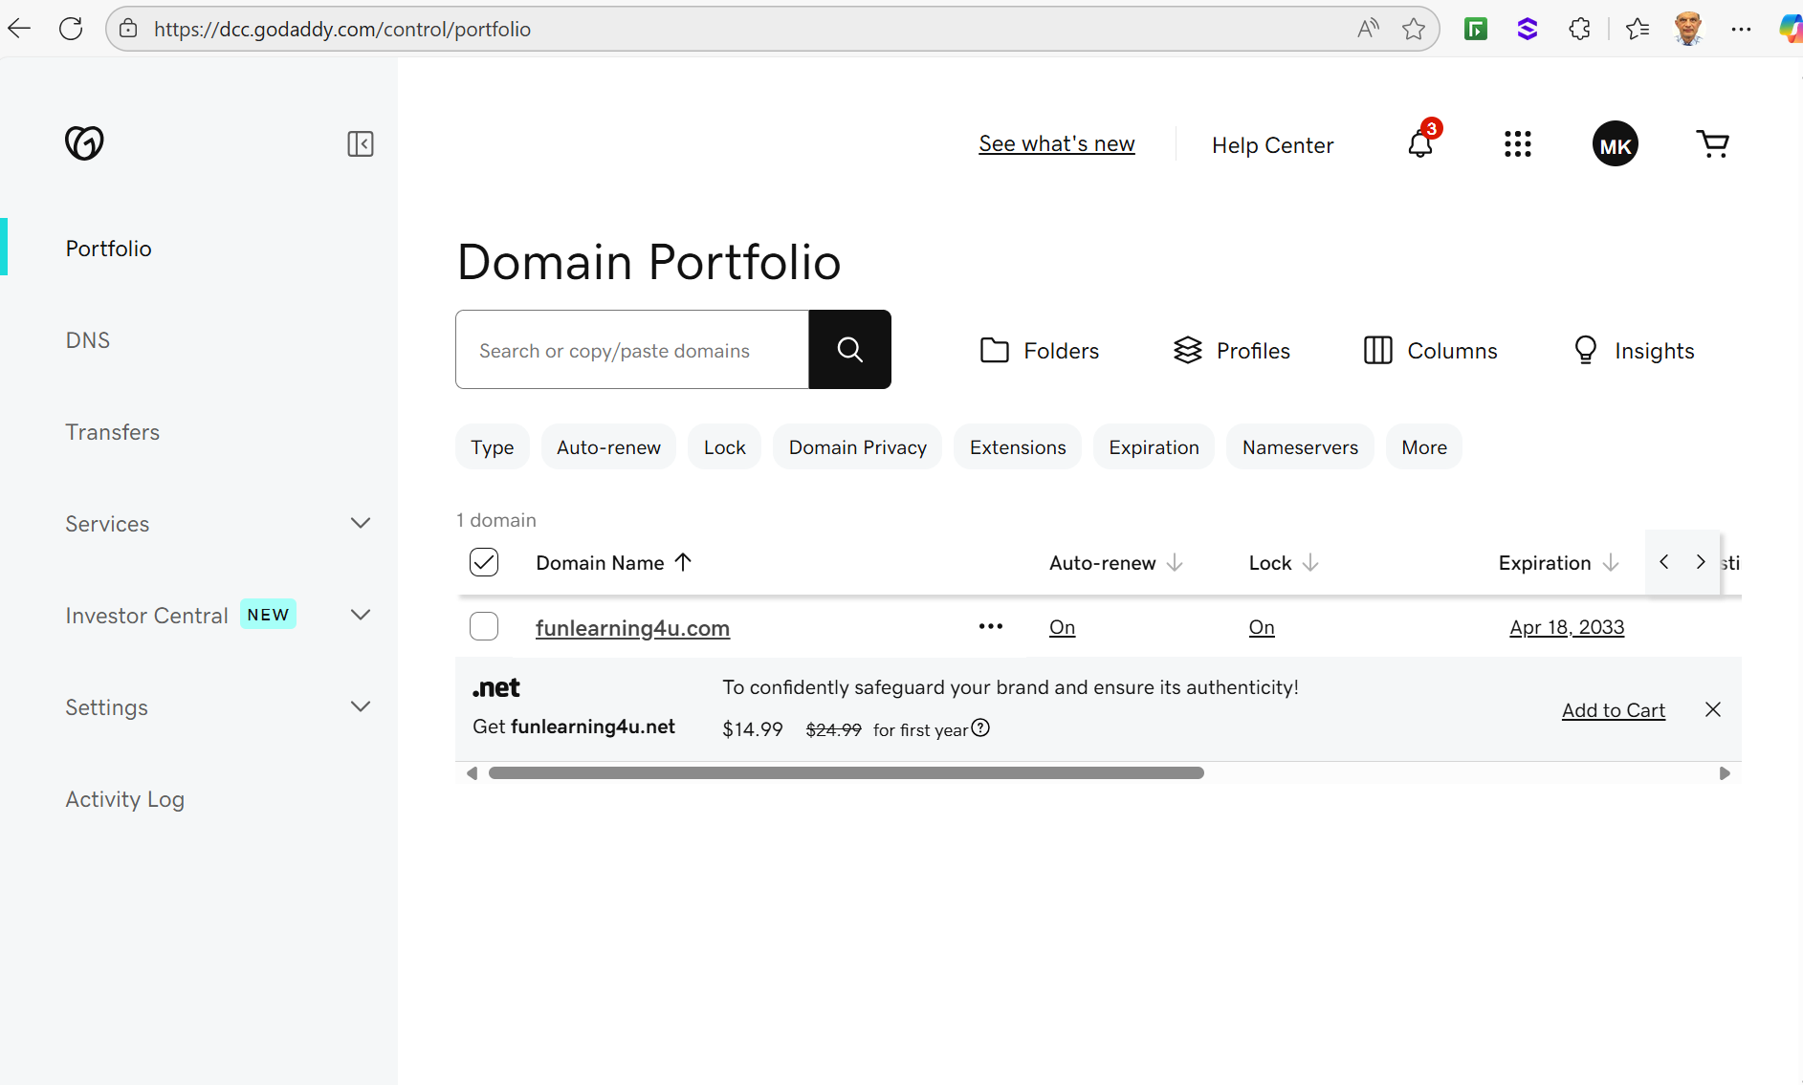

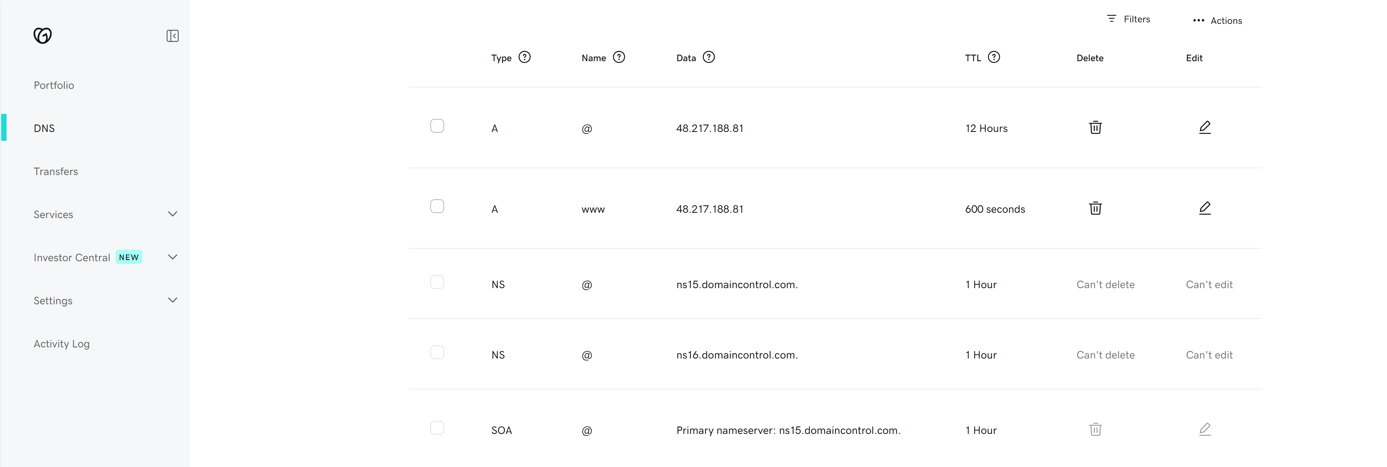
Add those records
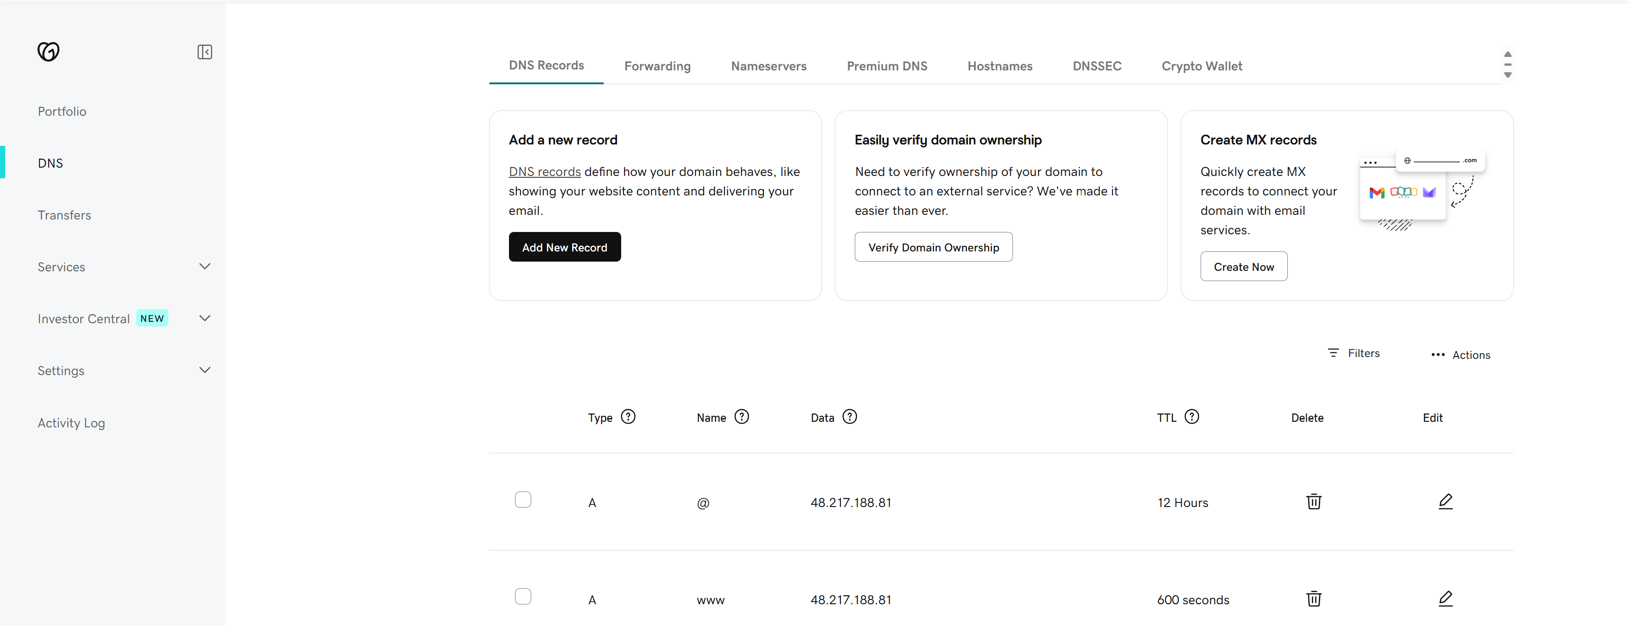
Click button to add records

- Add New Record
You will see a section called Records (A, CNAME, etc.)
  - Type: A
  - Name: @ (this refers to the root domain like funlearning4u.com)
  - Value: 52.160.55.10 (replace with your Azure VM public IP)
  - TTL: 600 seconds (or leave default)
- Add A Record for www (optional but recommended)
  - Type: A
  - Name: www
  - Value: 52.160.55.10
  - TTL: 600 seconds
- Save the changes.

If you want to edit/delete an existing record select the record
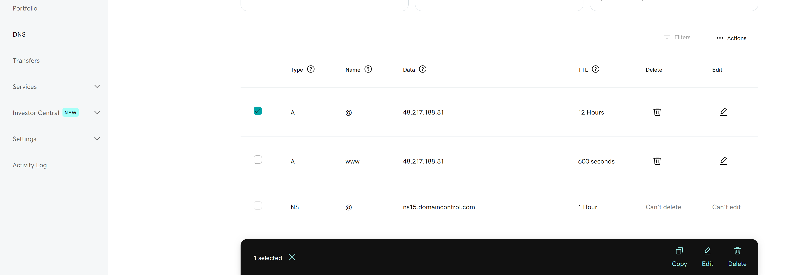
Select first
Edit Delete

✅ 1. Create .env file
In the root folder of your Flask project, create a file called .env:
nano /home/ubuntu/app/.env
Paste the following inside:
OPENAI_API_KEY=sk-xxxxxxxxxxxxxxxxxxxxxxxxxxxxxxxxxxxxxxxx
TWILIO_ACCOUNT_SID=ACxxxxxxxxxxxxxxxxxxxxxxxxxxxxxxxx
TWILIO_AUTH_TOKEN=your_auth_token_here
Save and close with Ctrl+O, Enter, then Ctrl+X.

✅ Step-by-Step: Get Your OpenAI API Key
1. Log In to OpenAI
Go to:
👉 https://platform.openai.com/account/api-keys
Sign in with your OpenAI account (same as ChatGPT).

2. Create a New API Key
Click the “+ Create new secret key” button.
Give it a name (e.g., twilio-bot or flask-app).
Click Create.
You will then see something like:
sk-XXXXXXXXXXXXXXXXXXXXXXXXXXXXXX
📌 Copy it immediately — you won’t be able to view it again later!

3. Use in Your App
You can set it as an environment variable in .env:
export OPENAI_API_KEY="sk-xxxxxxxxxxxxxxxxxxxxxxxxxxxxx"
load from .env securely:
from dotenv import load_dotenv
import os
load_dotenv()
openai.api_key = os.getenv("OPENAI_API_KEY")
Create / Select a Google Cloud Project
    - Sign In
  - Sign in at https://console.cloud.google.com
  - Click the project selector → New project → name it ClinicVoiceBot → Create → Select Project.
2 Enable Google Calendar API
- Left menu: APIs & Services → Library
- Search “Calendar API” → click it → Enable.

3 Configure OAuth Consent Screen
- OAuth consent screen>Branding
- App name : speech-AI-agent-help
- User support email: mmkhalil2001@gmail.com
4 Configure Audiance
- OAuth consent screen>Audiance
- User Type : External
- Test user : mmkhalil2001@gmail.com

5 Create OAuth Client ID (Desktop App)
- Select OAuth Consent Screen->client->Create client
- Application type: Desktop App.
- Name: speech-AI-agent-CID→ Create.
- Click Download JSON → save as speech_AI_agent/credentials.json.

6 Create / Identify Doctor Calendars
Look at the section Creating New (Secondary) Calendar for each doctor

if __name__ == "__main__":
main()
Run it once:
python3 generate_token.py
• Copy the URL → open in your laptop browser → sign in → click Allow
• Paste the code back into your MobaXterm terminal.
token.pkl is now in your project directory.

8 Reusable Calendar Helper7 One-Time Token Generation (generate_token.py)
See Generate Token From Window
9 Reusable Calendar Helper7 One-Time Token Generation (generate_token.py)

In the speech_AI_agent.py add the following

# ---------------- Google Calendar Auth -----------------
from google_auth_oauthlib.flow import InstalledAppFlow
from google.auth.transport.requests import Request

if not os.path.exists("token.pkl"):
flow = InstalledAppFlow.from_client_secrets_file(
"credentials.json",
scopes=["https://www.googleapis.com/auth/calendar"]
)
creds = flow.run_local_server(port=0)
with open("token.pkl", "wb") as token:
pickle.dump(creds, token)
else:
with open("token.pkl", "rb") as f:
creds = pickle.load(f)
if creds.expired and creds.refresh_token:
creds.refresh(Request())
with open("token.pkl", "wb") as token:
pickle.dump(creds, token)

10 Project Tree After Setup
speech_AI_agent/
├── speech_ai_agent.py
├── generate_token.py
├── .env
├── credentials.json
├── token.pkl # produced by step 7
├── admin_numbers.txt
├── doctors.txt
├── doctor_map.json
└── requirements.txt

10 Key Points to Remember
Topic | Notes
access_token | Expires ~1 hour (auto-refreshed).
refresh_token | Indefinite if refreshed at least every 6 months.
No user login during calls | Token is reused silently.
Change scopes later | Requires regenerating token.pkl (users must re-consent).
You now have a complete production-ready OAuth setup: calendars created, IDs stored, credentials.json downloaded, token.pkl generated, and helper code for automatic token refresh. Let me know if you need Cron/health checks or event-lookup utilities next!
✅ Step-by-Step: Get Your OpenAI API Key
1. Log In to OpenAI
Go to:
👉 https://platform.openai.com/account/api-keys
Sign in with your OpenAI account (same as ChatGPT).

2. Create a New OpenAI API Key
- Click the “+ Create new secret key” button.
- Give it a name (e.g., twilio-bot or flask-app).
- Click Create.
You will then see something like:
sk-XXXXXXXXXXXXXXXXXXXXXXXXXXXXXX
📌 Copy it immediately — you won’t be able to view it again later!

3. Use in Your App
You can set it as an environment variable:
export OPENAI_API_KEY="sk-xxxxxxxxxxxxxxxxxxxxxxxxxxxxx"
Or use it in Python:
python
import openai
openai.api_key = "sk-xxxxxxxxxxxxxxxxxxxxxxxxxxxxx"
Or better, load from .env securely:
python
from dotenv import load_dotenv
import os
load_dotenv()
openai.api_key = os.getenv("OPENAI_API_KEY")
Creating New (Secondary) Calendars for Each Doctor
This method is ideal for:
- Clinics with multiple doctors
- Keeping personal calendars separate from appointments
- Allowing shared control over calendars via email permissions

🔧 Step-by-Step: Create Doctor Calendars & Get Their IDs
🔹 Step 1: Open Google Calendar
Go to https://calendar.google.com — log in with the Gmail account your voice bot will use to manage appointments (same account used in credentials.json and token.pkl).

🔹 Step 2: Create a New Calendar
- In the left sidebar, find:
Other calendars ➕ → Create new calendar
- Name it:
  - For example: Dr. Ali Calendar
  - Description: Appointment schedule for Dr. Ali
  - Time zone: your local time zone
- Click Create calendar
Repeat for each doctor (e.g., Dr. Sara, Dr. Ahmed, etc.)

🔹 Step 3: Get the Calendar ID
- After creating the calendar, in the left sidebar, click the calendar name under “My calendars”
- Then click Settings and sharing
- Scroll to the section “Integrate calendar”
- Copy the Calendar ID — it will look like one of these:
✅ Examples:
  - dr.ali.clinic@gmail.com
  - h23k7a43j8f9o43f8h1@group.calendar.google.com (if created under a brand account or secondary account)

🔹 Step 4: Share Calendar With Others (Optional)
If other staff members (e.g., assistants or doctors themselves) need access:
- In the same Settings and sharing page
- Go to Share with specific people
- Click + Add people
- Enter their email address and set Permissions:
  - “Make changes to events” (recommended)
  - “See all event details” (for view-only)

🔹 Step 5: Add to doctors.txt and doctor_map.json
Update doctors.txt:
h23k7a43j8f9o43f8h1@group.calendar.google.com:Dr. Ali
98sdkf8s9sdf8sdf@group.calendar.google.com:Dr. Sara
Update doctor_map.json:
{
"h23k7a43j8f9o43f8h1@group.calendar.google.com": "Dr. Ali",
"98sdkf8s9sdf8sdf@group.calendar.google.com": "Dr. Sara"
}
Now your app will load the correct Calendar ID based on user request like “I want to book with Dr. Sara.”

✅ Summary of Files After Adding Calendars
File | Content
doctors.txt | Maps calendar ID → doctor name
doctor_map.json | Maps calendar ID → spoken name
credentials.json | Google OAuth secret downloaded from console
token.pkl | Reusable refreshable access token created with OAuth

Generate Token From Window

1. Prerequisites on Windows
- Install Python (if not already installed)
  - Download from https://www.python.org
  - During installation, check ✅ Add Python to PATH
- Create a working folder, e.g.:

- Copy these 2 files into it:
  - credentials.json (downloaded from Google Cloud Console)
  - generate_token.py (will be created in step 4)

✅ 2. Install Required Python Packages
Open Command Prompt or PowerShell:
pip install google-auth google-auth-oauthlib

✅ 3. Create generate_token.py
Create a file called generate_token.py with the following content:
python
import pickle
from google_auth_oauthlib.flow import InstalledAppFlow

def main():
flow = InstalledAppFlow.from_client_secrets_file(
'credentials.json',
scopes=['https://www.googleapis.com/auth/calendar']
)
creds = flow.run_local_server(port=0)
with open('token.pkl', 'wb') as token:
pickle.dump(creds, token)

if __name__ == "__main__":
main()

✅ 4. Run the Script to Generate token.pkl
From the same folder, run:
python generate_token.py
- This will open your browser with a Google login prompt.
- Login and approve access to the Calendar.
- Once successful, a file token.pkl will be created in the same folder.

✅ 5. Copy token.pkl to Ubuntu
You can use scp (secure copy) from Windows (PowerShell) or a tool like WinSCP.
Option A: Using scp in PowerShell:
scp token.pkl username@your-vm-ip:/home/ubuntu/speech_AI_agent/
Replace username and your-vm-ip with your actual SSH login details.

✅ 6. Verify on Ubuntu
SSH into your Ubuntu VM:
ssh username@your-vm-ip
cd /home/ubuntu/speech_AI_agent
ls
Make sure token.pkl is there.
Now your Python app on Ubuntu can use the Google Calendar API without running the OAuth process again.

Testing Procedure
✅ 1. Verify GoDaddy DNS Propagation
dig funlearning4u.com +short
dig www.funlearning4u.com +short
Both should return your public VM IP.
You can also use: https://dnschecker.org (enter funlearning4u.com and check A records globally).

✅ 2. Test HTTP-only Web Server (Before SSL)
Once you have set up the HTTP-only config and restarted Nginx:
curl http://funlearning4u.com
Expected: Should return your Flask app’s home page (or Welcome/JSON/text if that’s what your app returns).
Also try:
- http://www.funlearning4u.com in a browser
- Check for no redirect yet before certificate step

✅ 3. Validate Nginx Syntax & Status
sudo nginx -t
sudo systemctl status nginx
- Output should say: nginx: configuration file is ok and active (running).

✅ 4. Test SSL Certificate Generation
After running certbot:
sudo certbot certificates
You should see:
- Domains: funlearning4u.com, www.funlearning4u.com
- Expiry Date: should be 90 days ahead

✅ 5. Check HTTPS Redirect and Certificate
In a browser:
- Visit http://funlearning4u.com → should redirect to https://funlearning4u.com
- Use Chrome DevTools → Security tab to confirm the certificate is valid and issued by Let's Encrypt
Or use terminal:
curl -I https://funlearning4u.com
- Response headers should show: HTTP/2 200 or 301 with proper SSL certificate
To test the full redirect:
curl -I http://funlearning4u.com
Should return:
HTTP/1.1 301 Moved Permanently
Location: https://funlearning4u.com/

✅ 6. Flask App Running & Proxy Works
Check if Flask is running:
sudo systemctl status flaskapp
If running via app.py directly:
curl http://127.0.0.1:5000
If app is up, test through Nginx:
curl https://funlearning4u.com
Expected output should match your app’s response.

✅ 7. Test Auto-Renew Timer
systemctl list-timers | grep certbot
Should show a timer scheduled to run every 12 hours.
To simulate a full test renewal:
sudo certbot renew --dry-run
Expected: Congratulations, all simulated renewals succeeded.

✅ 8. Twilio Webhook Test
Use:
- Twilio Console → Voice → Webhook: https://funlearning4u.com/voice
- Use ngrok temporarily to test fallback Flask app logic locally if needed.
To verify Twilio can reach your server:
curl -I https://funlearning4u.com/voice
- Should return 200 OK or 405 depending on method (GET/POST) and Flask route config.
Enable Flask debug logging temporarily to see POSTs from Twilio:
app.run(debug=True)

✅ 9. SSL Grade Test
Check SSL configuration quality:
- https://www.ssllabs.com/ssltest/analyze.html?d=funlearning4u.com
Should return Grade: A or A+

✅ 10. Firewall and NSG Validation
Make sure the following are open:
- In Azure NSG: Inbound rules allow TCP 80 and TCP 443
- On your server:
sudo ufw status
- If enabled, check for:
  - 80 ALLOW
  - 443 ALLOW

Full Server Protection Setup for Nginx

🔧 Step 1: Install and Enable UFW (Firewall)
sudo apt update
sudo apt install ufw -y

# Allow essential traffic
sudo ufw allow OpenSSH
sudo ufw allow 'Nginx Full'

# Enable firewall
sudo ufw enable
sudo ufw status verbose

🛡️ Step 2: Install and Configure Fail2Ban
sudo apt install fail2ban -y
Then create a custom jail for Nginx:
sudo nano /etc/fail2ban/jail.d/nginx-404.conf
Paste the following:
[nginx-404]
enabled = true
port = http,https
filter = nginx-404
logpath = /var/log/nginx/access.log
maxretry = 5
findtime = 600
bantime = 86400
Now create the filter:
sudo nano /etc/fail2ban/filter.d/nginx-404.conf
Add this pattern to detect repeated 404s and .php scans:
[Definition]
failregex = <HOST> -.*"(GET|POST) .*\.php HTTP.*" 404
<HOST> -.*"(GET|POST) .* HTTP.*" 404
ignoreregex =
Then restart Fail2Ban:
sudo systemctl restart fail2ban
sudo systemctl enable fail2ban
✅ Check status:
sudo fail2ban-client status nginx-404

🔍 Step 3: Detect Suspicious IPs from Nginx Logs
To find top IPs scanning for .php files or triggering 404s:
sudo grep -E "GET .*\.php|POST .*\.php" /var/log/nginx/access.log \
| awk '{print $1}' | sort | uniq -c | sort -nr | head -20
✅ Optional: Check for all 404s:
sudo grep ' 404 ' /var/log/nginx/access.log | awk '{print $1}' | sort | uniq -c | sort -nr | head -20

📜 Step 4: Create Script to Monitor Bad IPs
sudo nano /usr/local/bin/nginx-bad-ips.sh
#!/bin/bash
echo "🔍 Top suspicious IPs from Nginx log:"
grep -E "GET .*\.php|POST .*\.php" /var/log/nginx/access.log \
| awk '{print $1}' | sort | uniq -c | sort -nr | head -20
Make executable:
sudo chmod +x /usr/local/bin/nginx-bad-ips.sh
Run with:
nginx-bad-ips.sh

🚫 Step 5: Manually Ban Bad IPs (Optional)
If you see an attacker IP like 123.45.67.89:
sudo ufw deny from 123.45.67.89
Unblock later if it is a false positive which means it is a good IP:
sudo ufw delete deny from 123.45.67.89

🔁 Step 6: Monitor Live Attacks (Optional)
Watch real-time abuse attempts:
sudo tail -f /var/log/nginx/access.log | grep -Ei "php|wp-admin|wp-login|sql"

✅ All-In-One Security Stack Summary
Feature | Enabled by | Notes
Firewall (UFW) | ✅ ufw | Blocks unauthorized ports
404 protection | ✅ fail2ban | Blocks IPs on repeated errors
PHP scan detection | ✅ fail2ban | Detects .php scans via regex
Bot IP monitoring | ✅ custom script | nginx-bad-ips.sh for log analysis
Manual blocking | ✅ UFW | Custom deny rules by IP

